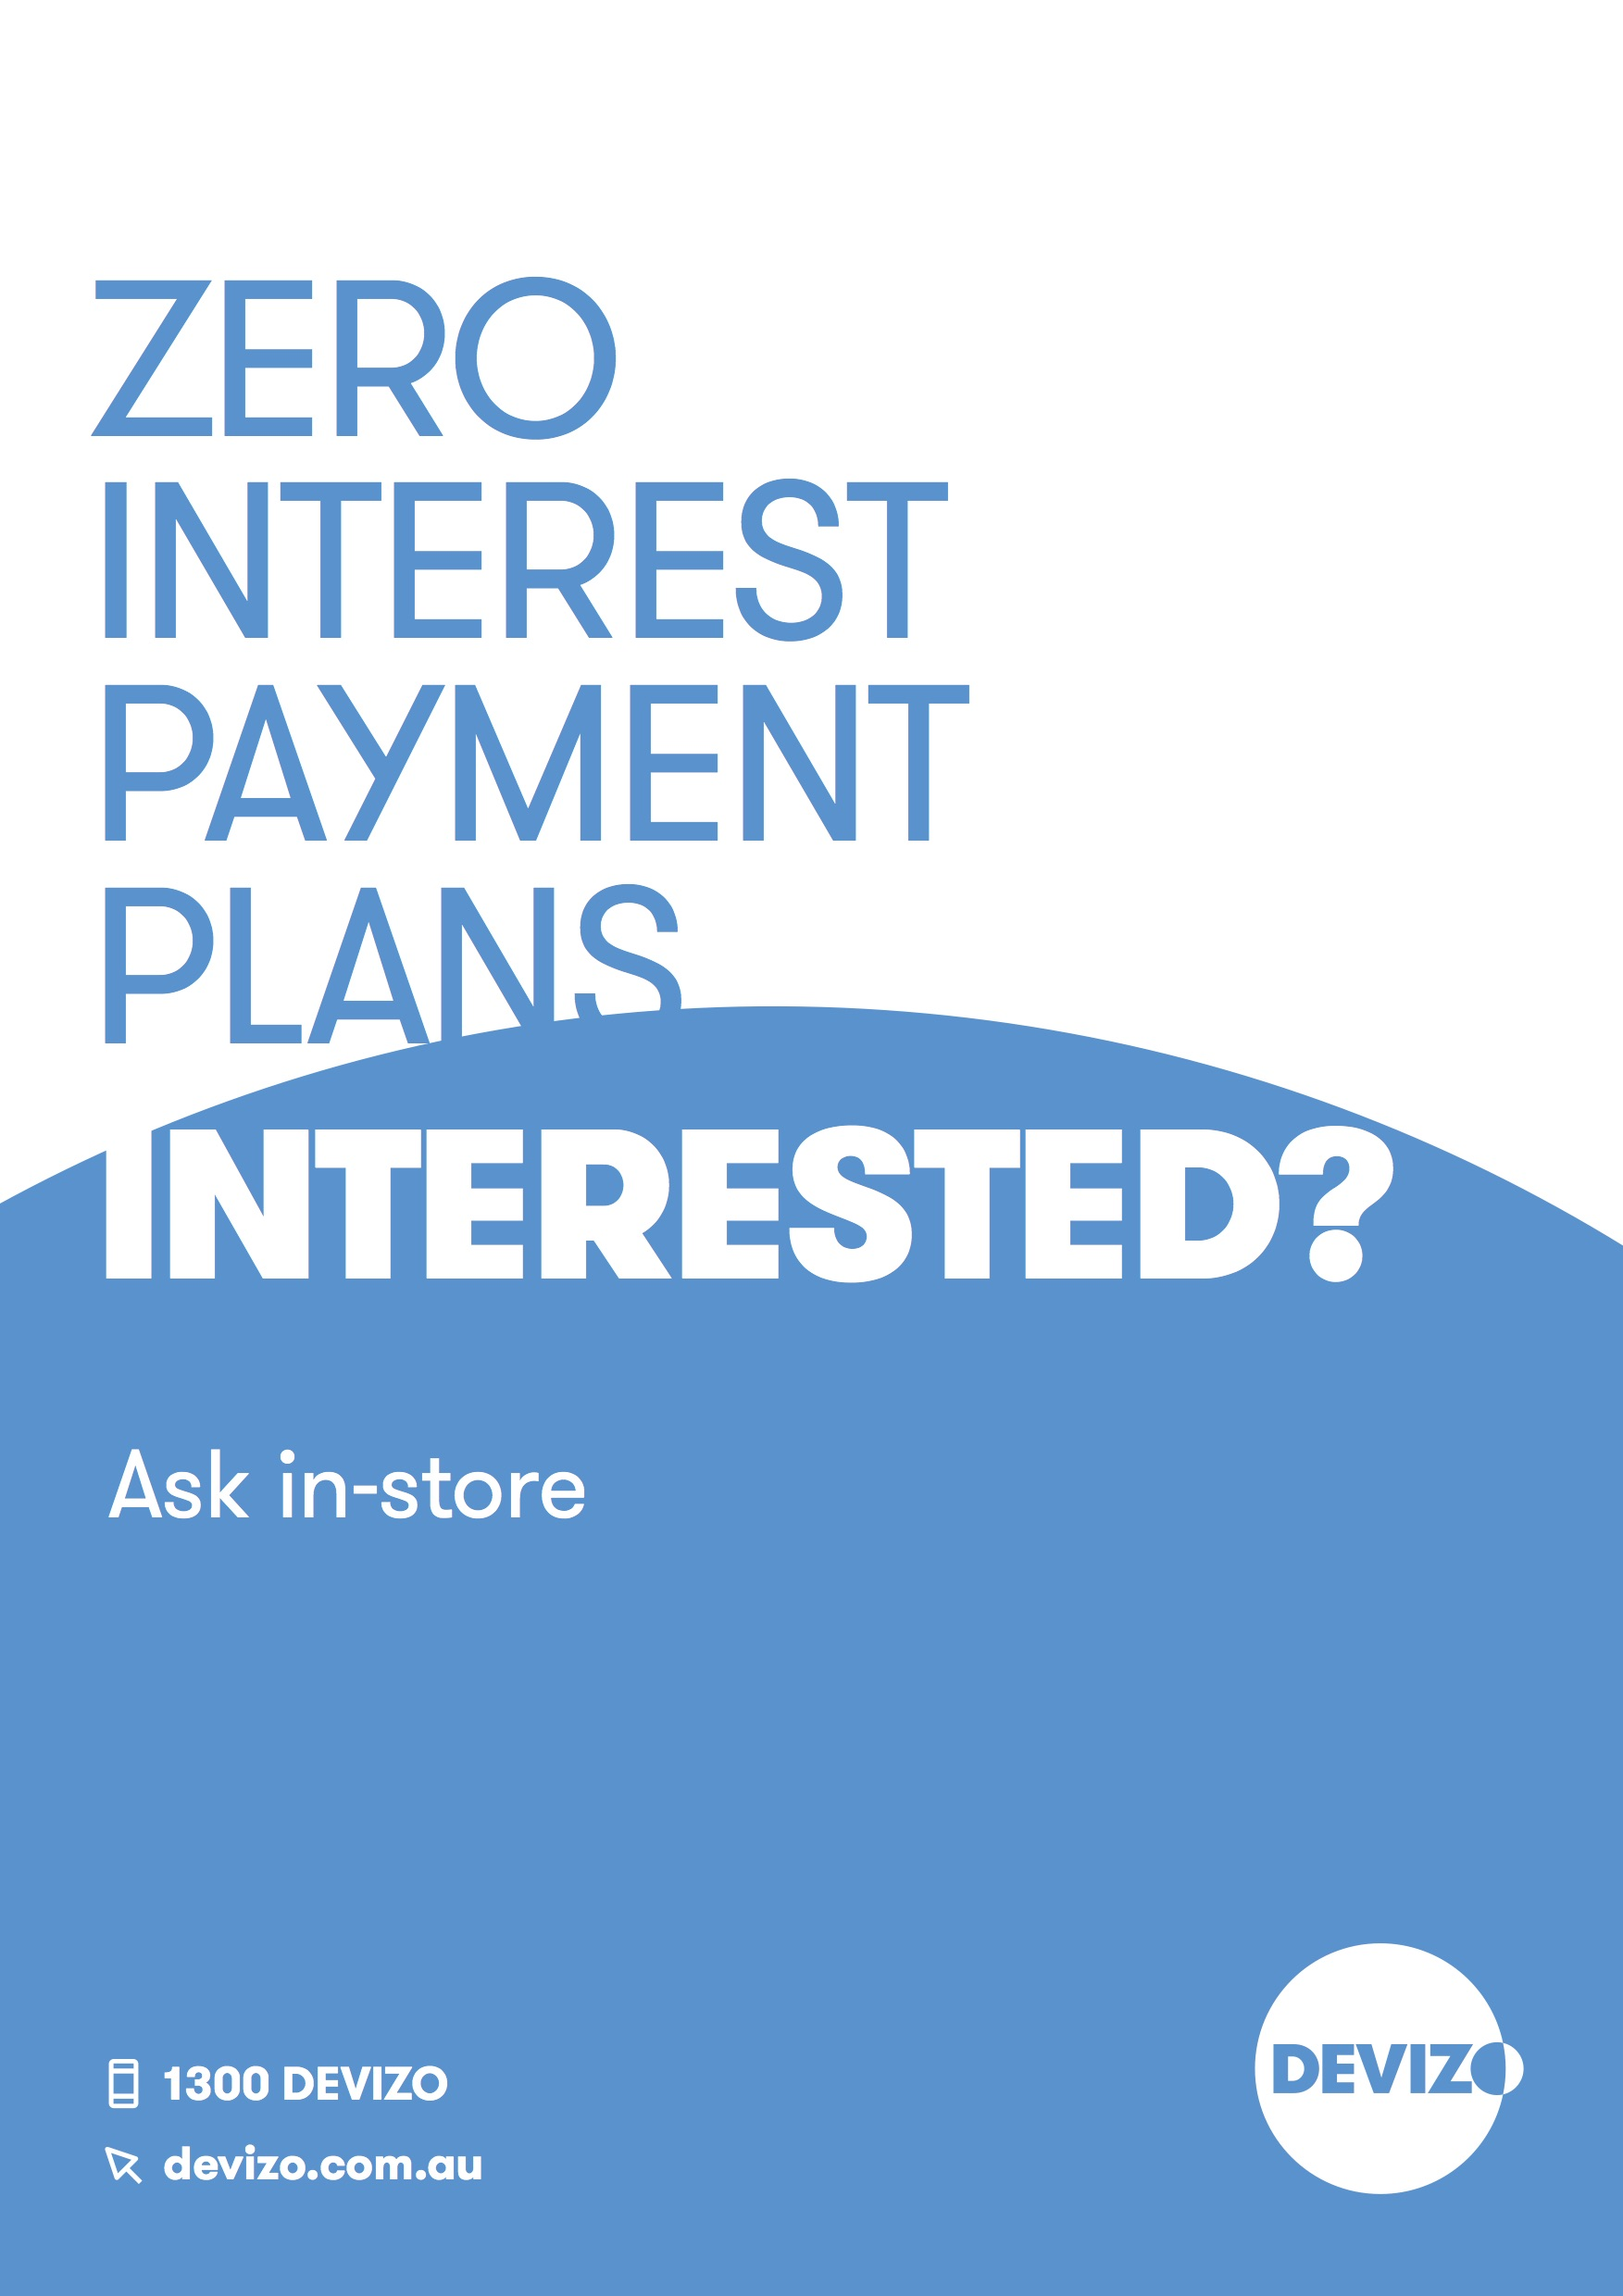

Devizo zero interest payment plans
Our simple and secure payment plans enable you to take your items home today, yet pay for them over time. And, with zero interest on purchases you only pay what your items cost. That’s why we’re one of Australia’s favourite in-store payment services.

It’s easy to pay with Devizo:
- Shop in-store for your items
- Apply in-store and get approved in minutes
- Take your items home today
- Pay over time with ZERO Interest
Please note. A min of 10% deposit is required at the point of purchase.

To apply you must be:
- Over 18 years of age
- An Australian resident
- Work more than 30 hours per week OR are an aged or veterans pensioner

To apply please supply your:
- Australian Drivers License or Aged or Veterans Pension Card
- Medicare Card
- Employment Details (Your employers’ name, suburb and phone number)
- Bank Details (Valid Credit card for deposit and continuous fortnightly payments)
- ABN if self employed.

Terms & Conditions:
- Minimum Purchase: $300
- Minimum Term: 3 months
- Minimum Deposit: 10%
Full terms and conditions apply, ask in store for details.

Fees & Charges
- Establishment Fee up to $60
- Monthly Account Keeping Fee $3.50
- Payment Processing Fee $2.90
Continuing credit provided by Devizo Pty Ltd.

For more information visit devizo.com.au

